Post Mortem

Sound Affect

Rover Vos

Student number: 12235834

Issues in Game Studies: microtransactions (780.224, 22W)

*Sound Affect(*Two cool Dudes, 2023*)* is a game(concept) that revolves around the player using different sound effects, soundtracks, etc. to build their character in a 2D top-down Battle royal shooter game. Each sound effect changes the stats of the player's character. We decided to not create the game, but to create a UI and use another game as the gameplay example. *Super Animal Royal(Pixile 2018)* has been used as the example game(*Figure 1*) in our prototype.

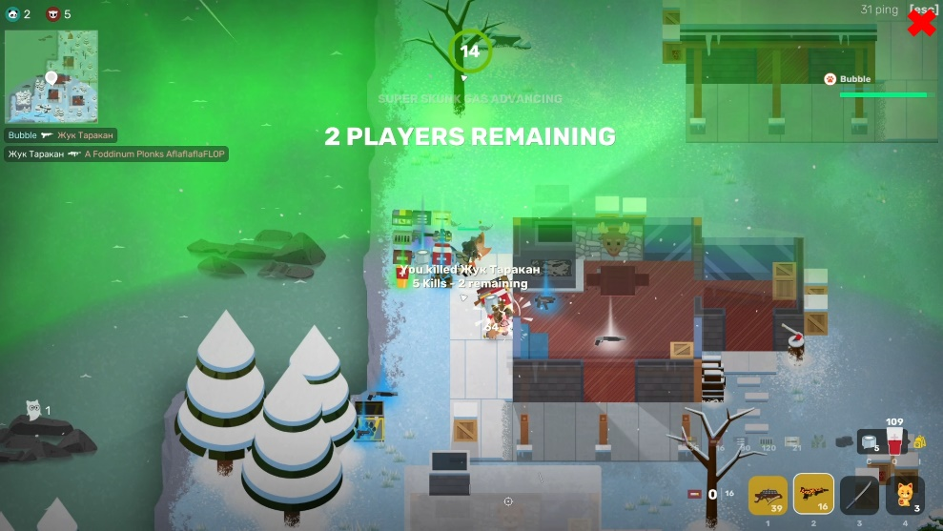

Figure Super Animal Royal Screenshot of gameplay video clip

We came up with the idea of Sound Affect during one of the microtransaction lectures where I pitched the idea of a game where instead of changing your weapons, armour etc. you change the sound effects your character/weapons make to change the stats of your character. Chris was very intrigued by the idea and we instantly started to brainstorm about it. After some weeks of casually chatting about the idea, we decided to use the idea for our final project.

The UI prototype we created has been built within PowerPoint (Figure 2). We decided on this, because with only a limited amount of time coding an entire game/UI would take too much time without it being a nice-looking and functioning prototype. PowerPoint allowed us to quickly and painlessly create a UI with many different sound effects, functionality, video, etc. build into it.

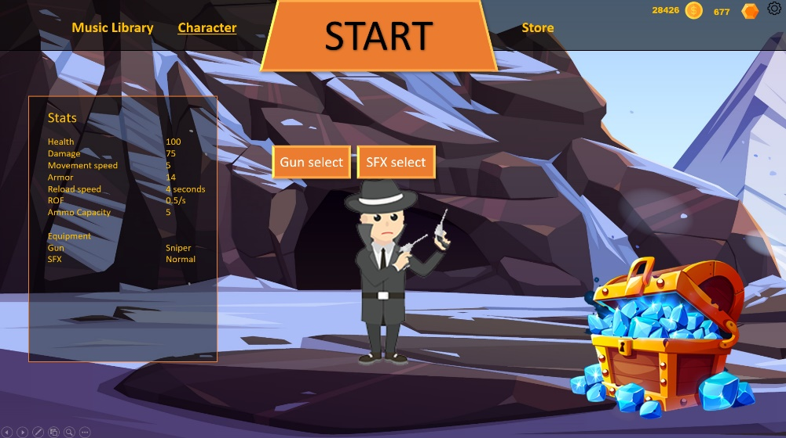

Figure UI Prototype Sound Affect

The project work was split between Chris and me. Chris made all the sound effects and modified a couple of video clips to showcase the effect of sound effects in the same scenario. I created the PowerPoint prototype where I implemented all the work Chris did and recorded the gameplay we used.

## Microtransactions

In *Sound, Affect* players can customize their character with different sounds. In the current prototype, you can change the sound your gun makes which changes the stats of your character. For example, changing from a normal sniper sound to a fart sniper sound increases the damage of the gun. If the game would be fully released you can also other sounds, everything except for world sounds(Wind, water, etc.).

The sound effects can be obtained in multiple ways. You can buy them with both, free currency obtained by playing the game and premium currency obtained by spending real money. You can also obtain loot boxes by playing the game or by buying them with premium currency. But it’s important to note here that everything is obtainable without spending real money. You can buy everything directly from the in-game shop with free currency.

Besides the sound effects, players should also be capable of changing their weapon/character skins to further customize their character. This would likely not change the stats of their character. Skins are obtainable in the same way the sound effects are.

Lastly to increase the value of the microtransactions we thought of the idea of an in-game(or a mobile app) where you can listen to and/or download the soundtracks you have bought. This way people can also listen to the game music outside of the game.

## Possible issues

Some of the possible issues in this game is the core game element of the game, sound. Many players don’t play games with sound on(At least that is what I have heard/experienced) and listen to their own music/series while playing games. Research would have to be done to see if this is true. Also, it would be interesting to see if this game changes the attitude towards the in-game sound of players. Also because of this, I think the gameplay needs to be extremely good and the sound should support the gameplay and not the other way around.

Another problem could occur with many different sound effects going off at the same time. When you hear 5 different and weird-sounding guns I can imagine that the soundscape of the game gets very confusing and overloaded. A good sound engineer would have to take a look at this possible problem. The quality of your speakers/headphones might also affect this.

## What I have learned

The creation of a prototype with PowerPoint was something I had never done before. I heard of people making full-fledged games with it so I thought why not try and make a UI prototype with it? I was pleasantly surprised at how good of a tool it is for this purpose. Everything you would need is built into PowerPoint. Sound effects, video, animations, easy image placement, cross-platform availability, text and basic shapes. PowerPoint even has a great media compressor saving many MBs. One of the problems I did encounter was that using many different animations/objects can make it rather cluttered to work with and at some point, PowerPoint will start to lag. Also, it is of course limited, there are no advanced options. All you can do is when you click a box animate something.

Microtransactions can be an interesting design element. I always thought that microtransaction are just a way to make money, and yes in essence it is. But I now also think it can be part of a game in a fun and exciting way(Or maybe this is wishful thinking/designer bias). If this game would only have the option to buy a sound and increase your stats I would see it as a money grab. However, if you add the fact that you unlock the music with it outside of the game it adds some value to the product you buy. This way it becomes something of a tangible product, not just a bit switched from 0 to 1. You now own the music and can download it, burn it onto a cd(Whoever still does that) and listen to it wherever you are.

Reference  
Pixile. 2018. *Super Animal Royale*. San Fransico: Modus Games.